Published by | Editor

HEWI
Marketing + Innovation

HEWI Heinrich Wilke GmbH
P.O. box 1260
D-34442 Bad Arolsen
Phone: +49 5691 82-0
presse@hewi.de
www.hewi.com

Reprint free - specimen copy requested

Panic bar glow
Visibly more safety
Even in the dark the panic bar glow shows the escape route out of the building in an emergency. Luminescent elements guarantee visible safety and orientation. The ambient light saves special pigments which shine in the dark, for instance in case of a power failure. The panic bar glow works completely without power and improves orientation on escape and emergency routes thanks to its fluorescent elements.

Well thought-through technology
The minimised mechanism with narrow gear unit allows a very streamlined design of the panic bar. Colliding of the door frame and panic bar is prevented by the narrow gear unit and the positioning of the bar on the inside of the gear unit This not only guarantees a large door opening angle, but also no jamming of double-leaf doors. The HEWI panic bar is therefore suitable for small passage widths. Precise fitting installation is particularly easy due to the telescopic extendability (710 – 1580 mm) of the panic bar.
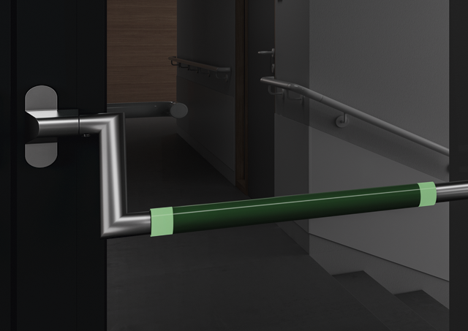
Panic bar glow

