Editor | Editorial office

HEWI
Marketing + Innovation

HEWI Heinrich Wilke GmbH
PO Box 1260
D-34454 Bad Arolsen
Telephone: +49 5691 82-0
presse@hewi.de
www.hewi.com

Reprint free - specimen copy desirable

Adiposity Products
Weight Capacity up to 300 kg
51 % of the men and 42 % of the women are overweight in Europe. Every fifth person is considered to be adipose. HEWI has developed products with a vertical support load capability of up to 300 kg especially for people who are severely overweight. The portfolio includes functions such as support, sitting and gripping and is designed for use in the care sector.
The care products are additionally reinforced to withstand high loads. The shower bench is available in two different widths and provides plenty of space and a secure hold. The handles not only have a high loading capacity but also have an enlarged gripping area, so that adipose patients can also safely grip the handle. The sanitary range is made of high-quality polyamide and is reinforced with an internal steel core.

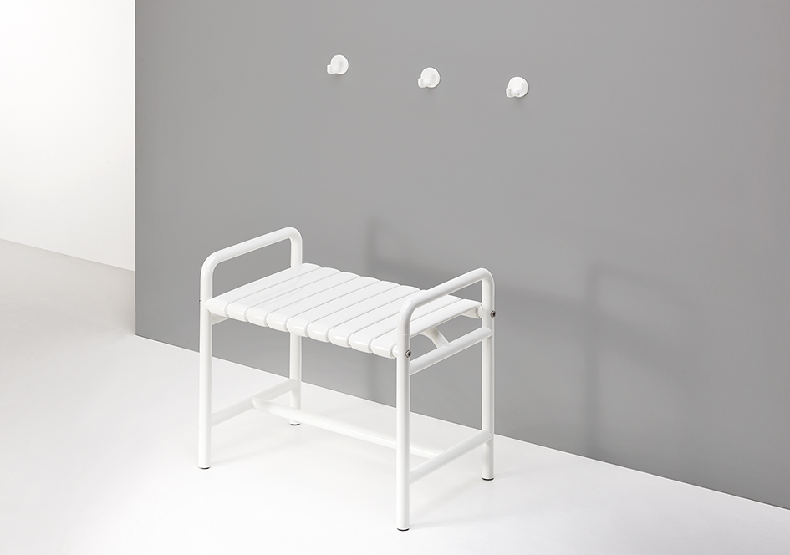
Shower Bench

For further information:

HEWI Heinrich Wilke GmbH
Postfach 12 60
D-34442 Bad Arolsen
Telefon +49 5691 82-0
eMail: info@hewi.de
Internet: www.hewi.com

