Published by | Editorial Office

HEWI
Marketing + Innovation

HEWI Heinrich Wilke GmbH
Postfach 1260
34442 Bad Arolsen
Germany
Phone: +49 5691 82-0
presse@hewi.de
www.hewi.com

Lisa Meyer-Floren
Phone: +49 5691 82-214
lmeyer-floren@hewi.de

Nicolo Martin
Phone: +49 5691 82-106
nmartin@hewi.de

Reproduction permitted, kindly provide sample copy

Accessories
System 900
System 900 offers a matching overall concept for sophisticated hotel bathrooms or homes. System 900 impresses in a wide range of areas of use and property types. Numerous awards prove that System 900 is the answer to the complex requirements of accessible bathrooms.
The design details reflect the sophistication of a concept. System 900 combined functionality and excellent design with durable, long-lasting quality, which creates added value.
New matching accessories are now available for the System 900 range, for example practical toilet roll holders with a cover or a shelf, new towel rails or toilet brush sets in stainless steel, chrome or with a powder-coated finish in white, shades of grey and black.
Universal products
In addition, numerous universal products, from waste bins, make-up mirrors and bath towel shelves to hairdryers or shower handsets ensure that everything can be obtained from one source.

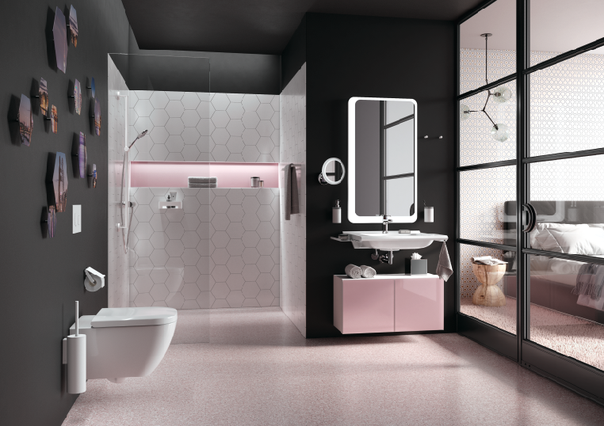
System 900: A matching overall concept from one source

HEWI | Hotel

All HEWI systems are based on the design principle of reduction down to the essential. The high-quality accessories for the areas vanity unit, shower and toilet in a minimalist design perfectly integrate into any hotel bathroom.
A wide range of materials and distinctive looks offer countless design options. Besides accessories, the range also includes accessible furnishing solutions and fittings.

